**WRITING A JAVA CODE TO CREATE A TABLE IN HBASE:**

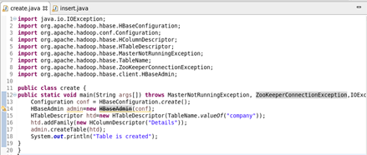

**TABLE IS CREATED IN HBASE BY RUNNING THE JAVA CODE (RUN AS APPLICATION) IN ECLIPSE:**

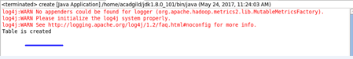

**USING ‘LIST’ COMMAND , SHOWING THE TABLES IN HBASE:**

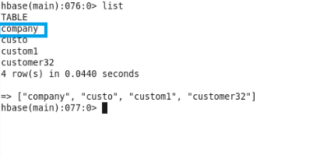

**WRITING A JAVA CODE TO INSERT DATA INTO THE TABLE “COMPANY” :**

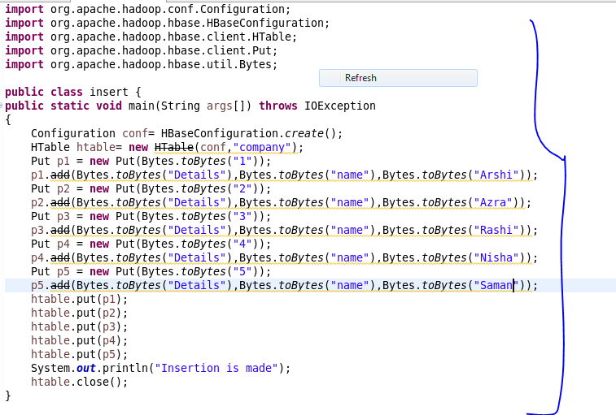

**INSERTION IS MADE BY RUNNING THE JAVA CODE IN ECLIPSE (RUN AS APPLICATION):**

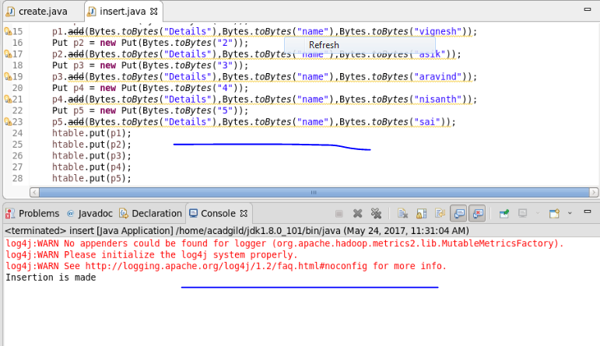

**HERE WE CAN SEE THAT INSERTION WAS SUCCESSFUL :**

